Dis-Eur-Greece-Agamemnon-Mask-Rephica

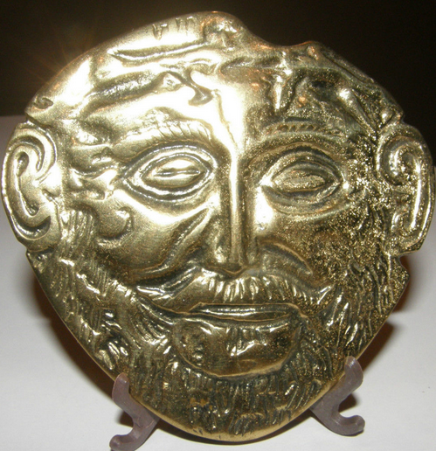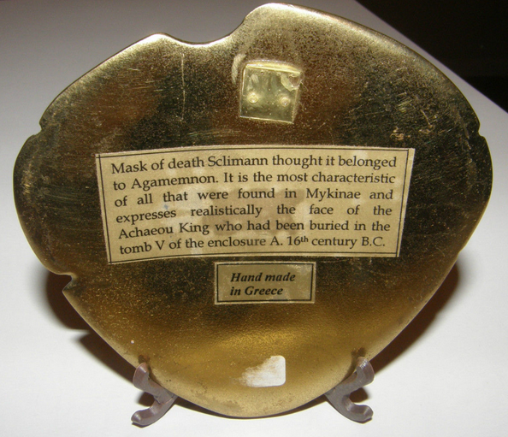

Death Mask of Agamemnon Greek Roman Mask - the back reads, "Mask of death. Schleimann thought it belonged to Agamemnon.  It is the most characteristic of all that were found in Mykinae and expresses realistically the face of the Achaeou King who had been buried in the tomb V of the enclosure A. 16th century B.C."

HAND MADE IN GREECE

Found at an Estate Sale in Houston, Texas - selling as found - not cleaned in any way.

Amazing detail - Solid Brass, measures approximately 3 5/8" tall x 3 7/8" wide.